A multi-modal Facial Recognition Framework for Continuous Attendance Tracking: Comparative Performance Evaluation
Rajesh Yadav ¹ Swati Gupta² Meenakshi Malik³
^{1,2}K.R. Mangalam University, Gurugram, Haryana,122103, India
³BML Munjal University, Gurugram, Haryana, 122413, India
Abstract: Facial recognition is regarded as a reliable biometric method yet it is used in classrooms certainly a surprise use case. Most institutions still depend on verification points in isolation, leaving ample scope for proxy attendance and other issues. To address these issues, we introduce real-time attendance framework that continuously scans the face using a deep neural network pipeline. The system records attendance every half an hour and verifies if a minimum of $80\%$ of students are present. It updates all operational events in the Firebase cloud interface which scales and responds when drop-deployed. The evaluation was done using a dataset of 1000+ authentic student videos. The videos were gathered in a conventional classroom, not in a controlled laboratory. As a result, the dataset entails intrinsic variations in lighting, pose, and background noise. All of the above factors create the problem of a recognition pipeline to be a realistic test bed. To comprehend the performance, both absolute and relative, of the recommended architecture, it was compared with a variety of existing models, such as SVM, vanilla CNN, Inception V3, MobileNet, and VGG 19. Our framework recorded $98.1\%$ training accuracy and $97.4\%$ validation accuracy with MobileNet being the closest competitor.
Statistical tests supported these actual trends. A one-way ANOVA showed that model architecture affected recognition accuracy at a significant level $(F\left(5,24\right)=1408.61, p<0.0001)$. Tukey’s HSD tests have shown that this proposed technique takes the best position. According to a paired two-tailed t-test, the presented framework performs better than MobileNet $(t=69.33, p< {10}^{-6})$. The Progress We Provide is Reliable and Reproducible. Ablation experiments’ results show that our dependency structure is non-robust. The results of the experiments show that the system works well and is reliable. It is compatible with institutional processes and efficiently operates with low human overhead at a large scale. The proposed system is feasible and efficient for large-scale continuous attendance monitoring.
Keywords: Facial Recognition; Automated Attendance System; Continuous Authentication; Deep Learning; HAAR Cascade; Real-time Monitoring.
- Introduction: The attendance recording of students is a much-required administrative task in higher educational institutions. It is critical as it is linked with the academic integrity of the respective institutions [1]. Moreover, they are expected to adhere to the respective guidelines. It is required in India as the UGC has a mandatory $75\%$ attendance criterion for the students to become eligible for the trimester courses. Even though it has now been established by law, there is still a heavy reliance upon old-fashioned methods like handwritten sign-in sheets and verbal roll calls [2]. These methods present substantial methodological problems. Outdated systems are not only ineffective and administratively overwhelming, but they are also subjected to systemic error and abuse, including widespread proxy attendance, forgery etc.

Continuing use of old systems is making some operating problems worse. Considering the growing strength of the student community and the difficulty of monitoring large lecture halls, it has become a tiresome and error-prone job to take attendance manually [3] [22]. This is particularly applicable to temporary academic staff such as visiting lecturers or guest faculty. The latest security arrangements for educational institutions require controlled entry to the classrooms which is often missed by the attendance tracking systems in place [5].

"Indian universities offer unique infrastructure and operational challenges." The digital solutions and automation that technological innovations are providing are not being integrated into systems that are useful for India’s universities. The majority of the systems out there are compartmentalized in such a way that they focus on either attendance monitoring or access control [5]. But, the two functions are not integrated well in any one of the systems. The study presents an original framework that simultaneously ensures the verification of students’ presence and non-intrusion while allowing safe real-time reporting for the administration [6]. Thus, it meets a serious demand for all-encompassing institutional administration systems.
Facial recognition is a biometric authentication that is non-invasive [7]. It is an effective method of identifying people. Moreover, it compares a live image with a stored one. Due to the advent of deep learning, mainly the Convolutional Neural Networks (CNNs), these systems are now more accurate and robust [8]. In fact, these operators are now able to work in complex real-world situations.

Monitoring student attendance is one of the most important administrative functions [9]. It impacts evaluation of students and also the institution. Many issues arise here, with options like contact-based biometrics or manual sign-ins [10]. According to the research, a large number of children are just proxy attending school since the classes get very lengthy and contact-based methods get to use the hygiene issues happen [11]. Universities in India have witnessed a significant increase in registrations, creating a challenging situation. When percentage attendance is not calculated correctly, the implementation of the University Grants Commission (UGC) 75% attendance norm is weakened. The norm also creates accountability gaps for personnel including adjunct/visiting lecturers.
In addition, another risk that is frequently ignored is the security vulnerability of big lecture theatres [12].

AI based facial recognition systems can offer a solution for automated attendance but most solutions only focus on biometrics logging [19]. There is a huge research gap for integrated technologies which are capable of simultaneously addressing attendance accuracy, security monitoring in real-time as well as administrative automation in many developing countries whose resources are limited [20].

This study proposes a unique and systematic framework for an Intelligent Live Attendance System that serves as a solution. The system is made specifically for the academic institute context and it contains three basic functional pillars.

- Automated Attendance Tracking: Using video camera system with OpenCV Haar Cascade model was used on real time multi face detection and recognition with pre-registered database which thus automates entire logging process.
- Regulatory Compliance & Administration: It automatically computes total attendance to ensure compliance with the 75% UGC requirement and increases accountability of visiting faculty by providing authenticated records for payment processing.
- Enhanced Security Protocol: The framework has a security module that can detect and alert supervisors about unauthorized students in classrooms.

This initiative aims to create all three of these components and integrate them into a combined scalable platform. The proposed system goes beyond tracking attendance by protecting and automatically tracking as they happen and it is believed to be a more comprehensive solution than previous systems and a suitable one for reinforcing the integrity of institutions and improving the functioning of demanding academic environments. This study is organised to present a complete evaluation of the development of an advanced real time attendance system using facial recognition. This paper is organized as follows Section 2 gives the context of the study, articulation of the problem, and limitations of the proposals. The state-of-the-art facial recognition technology for attendance is analysed in Section 3. In Section 3, we talk deeply about the architecture of the proposed system. It describes the methods we used, the major algorithms and ways to process data, and the main things we need for implementation. Section 4 describes the experimental set-up and the evaluation metrics. The results section describes the findings and critiques the results empirical findings and measures the system against its objectives. Section 5 concludes the paper by summarising the key findings of the study, its academic and practical implications, and recommendations for future studies.

- Literature Review
The facial recognition usage has been gradually used for automated attendance system and can serve as an alternative to manually and contact-based authenticating methods. Earlier investigations have looked into various algorithmic methods and hardware configurations, each of which yields significant findings in accuracy, computational efficiency, and feasibility [21]. Despite these accomplishments, there remain many research gaps. Some of them include longitudinal studies, large scale classroom studies, real-time multi-face identification and integration/administration. This review of literature combines related papers into two topic areas and indicates the gaps which warrant the present study.
  - Architectures with Significant Hardware Requirements
Bhavikatti et al. in the study [14] suggested a facial recognition system using FPGAs that operates on Local Binary Patterns (LBP). The system is optimized for minimum memory usage and reduced processing time. The method shows good hardware usage and performance on the ORL dataset; however, it relies on static image matching and does not solve the complexities of real-life classroom scenarios characterised by multiple moving subjects, variable illumination and occlusions. FPGA-based designs need specific hardware. Generally, that hardware is not available at the colleges. So, it limits their scalability and usability.

Hassan et al. in the study [11] proposed the hybrid CNN–AdaBoost model runtime on Raspberry ${Pi}_{4}$resulting in high accuracy under controlled environments. This system is practical on cheap hardware, but the system's evaluation is limited to a small data set of eight students, which raises questions about the generalizability of the classroom implementation. In addition, the system performs the recognition on a single frame and does not have the ability for continuous authentication or attendance verification over a long period of time.

Shayea et al. [12] expand attendance tracking based on facial recognition to encompass school safety surveillance via the identification of fighting actions. Their architecture utilizes Haar Cascade and a ResNet-based recognizer, achieving $90-92\%$ accuracy. The method is hampered by webcam-based identification, inadequate spatial resolution, and dependence on IoT messaging protocols for notifications, rendering it inappropriate for large-scale classrooms where simultaneous and consistent recognition of several faces is required during session durations.

In the study [13] Eddine at. al designed a system for recognition based on CNN with Raspberry ${Pi}_{4}$, achieving a rate accuracy of $94\%$ on the usual databases which are ORL, FERET, and Face94. Although it has a light architecture, the system is primarily executed on standard datasets instead of real uncontrolled recordings of students. It also can’t monitor more than one face, guarantee temporal consistency, or check continual attendance.

Research Gap 1: Most systems today are hardware-centric and lightweight. They focus on single-image, single-face identification only. This means they cannot provide an effective solution for continuous, real-time attendance capturing in a dynamic classroom environment.

  - Photometric-Variant-Sensitive Models
The paper [15] proposed an area metric-based approach from face landmarks through geometric curves to distinguish identical twins This method can manage subtle differences in the faces but requires high-quality dense landmarked face images. Moreover, its performance assessment was done on well-controlled datasets such as ND TWINS and 3D TEC. These methods are sensitive to stance variations, illumination changes, and motion blur, which frequently arise in classrooms.

Chandrashekar et al. in [16] proposed a framework called RMSM to deal with the single-sample-per-person (SSPP) problem using Viola–Jones detection SC-CNN for feature extraction and a pattern-matching classifier. Even though the structure improves the SSPP, it still relies on Viola–Jones, which is known to degrade in changing light and angle conditions. The system is mainly tested on curated SSPP datasets and does not support continual or multi-face recognition.

Arifin et. al. in the study [18] merge pupil measurement with facial emotion recognition through application of CNN and landmark-based characteristics. This study on affective computing in education relies on Haar Cascade for face detection, which is known to be ineffective at low resolution or occluded faces. The system focuses on analyzing emotions instead of determining whether attendance is genuine. Furthermore, it does not offer ways to stop proxies, monitor constantly, or implement broadly.

Research Gap 2: The accuracy of photometric-sensitive as well as landmark-based approaches has been shown to improve. However, they are still susceptible to real-world classroom variations, which include poor lighting, partial occlusions, head pose variations, and large number of students.

The studies evaluated reveal great progress in automated systems of monitoring; however, a few critical shortcomings remain unresolved. Most state-of-the-art methods rely on facial recognition from snapshots rather than real-time monitoring. As such, these methods are not able to verify full session attendance and identify late comers and early exits. Difficulty in scaling appears to be a hurdle. A few studies evaluate their models on limited and controlled datasets instead of large and real classroom settings with many students. Also, modern face-detection systems, especially those based on Haar Cascade or Viola–Jones, find it challenging to detect and trace numerous faces in dynamic scenes with $50-70$ faces. Another shortcoming is the lack of interaction with institutional operations, as earlier systems did not possess automated attendance calculation, session validity levels, cloud synchronization, admin dashboards, or security surveillance functions. In the end, most systems are not evaluated in real-life classroom scenarios with motion blur, occlusions, changing lighting conditions, varying camera positions, moving students, and noise from other classrooms. All this limits their usability. These shortcomings an integrated real-time attendance system which is comprehensive, scalable, and fully integrated and suited for real-life classrooms.

- Research Methodology
This research's methodological approach includes a comprehensive end-to-end pipeline that converts primary class video recordings into a real-time automated attendance system based on deep learning. The first stage of the process is dataset generation and then video processing, followed by facial extraction, model development, training, deployment, and complex statistical validation. This system is meant to work in ‘real world’ classroom situations where lesson length is between forty and ninety minutes, class sizes are from forty to seventy-five students, and lighting conditions change significantly. The following sub-sections will present the detailed and comprehensive working process along with actual numerical values achieved through experimental implementation of the process.
  - Dataset Preparation and Organization
The data set that was used to train the model consists of one thousand different directories, each containing a different student on a course. On average, there is one video per folder, with the average video duration being 62.4 seconds (41 to 84 seconds). The dataset has a size of 18.6GB after the first preprocessing, while the size of the single video files is between 68MB to 192MB.
Every student gets a folder with their scholastic roll number, like 23BCA10014 in this case. The naming convention allows for easy identification of student retrieved facial photos. The system detects 1006 files and it checks 1003 which tend to have at least one legit video file, so the remaining 3 directory is auto excluded and gets recorded during the pre-processing. The folders contain approximately 1 file because several learners provided 2 videos for clarification.

The dataset checker runs through the folder tree in about 17.82 seconds to check for valid movies and missing or corrupted files. Out of all the pupils there are 1003 distinct video files identified.
  - Video Ingestion and Face Extraction
    - Frame Sampling Strategy
Videos captured at 30 frames per second (FPS) produce, on average, 1,800 frames per minute of content. To enhance processing efficiency and minimize redundant processing, the system samples every fifth frame, thereby decreasing the overall number of processed frames to roughly $20\%$ of the original set. For a standard sixty-two second video at thirty frames per second, the system processes approximately:
$$\frac{60*30}{5}=372 frames per pupil$$
This sampling method reduces processing power by about 80% while still maintaining intra-personal variability, including blinks, head tilt, gaze direction, and expression changes.
The algorithm extracts a maximum of fifty faces from every video. The limit is there so no student with a lengthy video submission biases the model from training. Based on experimental observations, the system meets the limit on approximately 64% of the videos.
  - Face Detection Using Haar Cascade Classifier
Changing each processed frame to grayscale reduces every pixel from three channels to one channel hence reducing the computing complexity by 66%. Face detection uses the Haar Cascade filter with a scale factor of 1.1 and minimum neighbour threshold 5 which are optimized after several trials. The trials improve accuracy.

During the processing of the dataset, the classifier achieves a mean detection accuracy of 97.4% when manually verified on an arbitrary number of 1,000 frames, with a false-positive rate of 3.2% and a false-negative rate of 6.8%. To ensure quality, we remove features below 50×50-pixel size for further analysis. The algorithm detects a cumulative sum across all videos of.
Approximately 1003 students, each contributing around 40 to 50 faces, gives an estimated total of 40,120 to 50,150 usable facial photos. This amount doesn't vary too much since students who generate more quality movies generate more distinguishable frames.

  - Preprocessing and Normalization
Each clipped face is scaled to 128×128 pixels, resulting in 49,152 colours in RGB per image. The resizing process succeeds in 98.4% of instances; the remaining 1.6% of frames are deleted owing to distortion, occlusions, or harsh illumination conditions. The complete collection of pre-processed faces utilizes around 265 MB of RAM when placed into memory for model training.

  - Model Architecture Design
The deep learning model used for face recognition is a custom-designed CNN architecture containing 21 trainable layers with 3.8 million parameters. The architecture is optimized for execution speed and high recognition accuracy, targeting deployment on consumer-grade hardware.
    - Convolutional Feature Extractor
The convolutional feature extractor operates on an input image of shape 128*128*3 and is organized into three successive convolutional blocks. Each block contains two 3*3 convolutional layers (padding=same, stride) followed by a 2*2 max-pooling layer (stride 2). The sequence of filter depths is $32 →64→128$. All convolutional layers use ReLU activations.
    - Spatial dimensions and channel counts after each block.
Because each convolution uses padding=same and stride 1, the spatial resolution is preserved through the two convolutions in each block and is reduced only by the following 2*2 pooling (stride $2$). Starting from the input spatial size
$$128*128$$
the successive pooling operations halve the spatial dimensions at the end of each block:
$$128*128→64*64→32*32→16*16$$
Thus, within every block the two $3*3$ convolutions keep the current spatial size, and the single 2*2 max pool at the block's end performs the halving shown above.

Block 1: Two convolutional layers with 32 filters each preserve the spatial size at 128*128 during convolutions. After the 2*2 pooling, the spatial dimensions become $\frac{128}{2}=64$ for both height and width. Thus, the Block-1 output tensor has shape $64*64*32$ The number of scalar activations (spatial features) in this tensor is computed as:
$$64*64*32=\left(64*64\right)*32=4096*32=131,072$$

Block 2: The two convolutional layers operate on the Block-1 output and preserve the spatial size until pooling. After the 2*2 pooling, the spatial dimensions become$\frac{64}{2}=32$. With 64 filters in Block~2, the output tensor has shape $32*32*64$. The number of scalar activations in this tensor is:
$$32*32*64=\left(32*32\right)*64=1024*64=65,536$$

Block 3: After the two convolutional layers and the final $2*2$ pooling, the spatial dimensions become $\frac{32}{2}=16$, with 128 filters. Therefore, the Block-3 output tensor has shape $16*16*128$. The number of scalar activations in this tensor is:
$$16*16*128=\left(16*16\right)*128=256*128=32,768$$

Table 1 delineates the disparity between the accurate pooled feature-map dimensions and the erroneous pre-pool interpretations that may inadvertently exaggerate the feature count. The model uses an actual flattened vector of 32,768 features taken solely from the last block (16×16×128). The total of all pooled activations is 229,376, while the sometimes-misunderstood pre-pool value of 524,288 derives from Block 1 prior to pooling. This explanation guarantees precise reporting of the network's spatial feature dimensionality.
Table 1 Comparison of Spatial Feature Counts: Correct Pooled Outputs vs.\ Misinterpreted Pre-Pooling Activations
Block | Pooled Output Size | Pooled Activations | Pre-Pool Activations
Block 1 | $$64*64*32$$ | 131,072 | $$128*128*32=524,288$$
Block 2 | $$32*32*64$$ | 65,536 | $$64*64*674=262,144$$
Block 3 | $$16*16*128$$ | 32,768 | $$32*32*128=131,072$$
Sum of all blocks | - | 229,376 | 917,504
Final Flattened Vector $16*16*128$ 32,768 (Correct Feature Count Used by Model)

    - Flattening and the correct number of features
The common pattern in CNN architectures is to take the output of the \emph{final} convolutional block and flatten it before passing it to the dense layers. In this model, the final tensor has spatial dimensions $16*16*128$ channels. Thus, the total number of scalar activations is
$$16*16*128=32,768$$
These 32,768 values constitute the feature vector that is fed into the first fully connected (dense) layer, assuming that only the last block's output is flattened rather than concatenating earlier blocks.
  - Receptive field growth
The receptive field is the size (in input pixels) of the image region that influences a single activation at a particular spatial location in a feature map. The receptive field grows with each $3*3$ convolution and doubles in effective sampling stride with each $2*2$ pooling layer (stride 2). Using the standard incremental calculation where for a layer with kernel size $k$ and stride $s$,
${RF}_{new}= {RF}_{old}+\left(k-1\right).{Stride}_{old, } {Stride}_{new}= {Stride}_{old}.S$
we compute the receptive field at the final feature map exactly as shown in Table 2.

Start with receptive field $RF=1$ and total $Stride=1$ at the input pixel level.
Table 2: Receptive field and total stride progression across layers.
Layer | Receptive Field (RF) | Total Stride
After Layer 1 (Conv 3*3, stride1) | 1+(3-1).1 = 3 | 1
After Layer 2 (Conv 3*3, stride1) | 3+(3-1).1 = 5 | 1
After Pool1 (2*2, stride 2) | 5+ (2-1).1 = 6 | 2
After Layer 3 (Conv 3*3, stride1) | 6+(3-1).2 = 10 | 2
After Layer 4 (Conv 3*3, stride1) | 10+(3-1).2 = 14 | 2
After Pool2 (Conv 2*2, stride2) | 14+(2-1).2 = 16 | 4
After Layer 5 (Conv 3*3, Stride1) | 16+(3-1).4 = 24 | 4
After Layer 6 (Conv 3*3, Stride1) | 24+(3-1).4 = 32 | 4
After Pool3 (2*2, stride 2) | 32+(2-1).4 = 36 | 8
Therefore, a single spatial activation in the final $16*16$ feature map corresponds to a $36*36$ patch in the original input image. This means that each final-layer feature aggregates information from a localized $36*36$ region of the $128*128$ input; stacking deeper layers and introducing dense connectivity enables the network to progressively compose larger, more integrated, and more abstract patterns from these local receptive-field detectors.
  - Batch Normalization
Batch normalization is applied after each convolution. It normalizes each channel’s activations to zero mean and unit variance, followed by learned scale $γ$ and shift $β$ parameters. In practice, batch normalization stabilizes layer inputs, reduces internal covariate shift, enables higher learning rates, and speeds up convergence. In our experiments, activation variance decreased by approximately $27-31\%$ with batch normalization (e.g., $0.85 →0.62$, giving $\frac{0.85-0.62}{0.85}≈27\%$) , which helps suppress extreme activations, improves optimizer stability, and provides mild regularization.
  - Dropout Regularization
We add Dropout layers after pooling, with dropout probabilities chosen from [0.25, 0.5] and dense layers. Dropout nullifies a fraction $p$ of activations during training making it less likely that co-adaptation occurs and encouraging more robust feature learning (e.g. $p=0.2525\%$ of units dropped in an update). Dropout also acts like model averaging because it helps networks. Using dropout simulates a collection of thin sub-networks, with a total of $2^{N}$. At inference time, Disabled dropout ensures proper scaling of activations to produce outcomes. Dropout rates in the range $0.25-0.5$ work empirically well medium sized CNNs of these types.
  - Activation function choice (ReLU) and initialization
The ReLU activation function is used for all convolution layers. It is computationally efficient. It also creates a sparse activation of the neurons. Thus, it helps to alleviate the vanishing gradient problem for positive inputs. He et al. initialization is recommended for ReLU-based networks, as it modifies the weight variance according to the number of input channels, thereby improving initial training stability. Keras/TensorFlow frameworks presume defaults like [10] or [17] initializers depending on layer setup, however, for optimal reproducibility and performance with ReLU, it is best to specify kernel_initializer='he_normal' in production tests.
Table 3 presents a complete summary of data processing and model preparation activities such as dataset composition, frames sampled, face detection, pre-processing, CNN architecture and more.
This pinpoints some crucial statistics, such as the number of real films, extracted facial images, Final feature dimension (FD) and receptive field (RF) expansion. The table mentions the activation functions, normalization, dropout and initialization used in the face-recognition system proposed in this paper.
Table 3: Summary of Dataset, Video Processing, Face Extraction, and Model Preparation Pipeline
Stage | Key Details and Statistics
Dataset Composition | 1006 student folders; 1003 valid video folders.  Average duration: 62.4 sec (41-84 sec).  Dataset size: 18.6GB; video size: 68-192MB.  Folders named using roll numbers (e.g., 23BCA10014).
Integrity Scan | Scan time: 17.82 sec  Total valid videos: 1003  Average videos per student: 1.1
Frame Sampling Strategy | 30 FPS videos $(≈ 1860\$ frames/min)$  Every 5th frame sampled (20%).  Typical video: 372 processed frames.  Max 50 faces per video; cap reached in 64% of videos.
Face Detection (Haar Cascade) | Grayscale conversion reduces computation by 66%.  Parameters: scale factor = 1.1, minNeighbors = 5.  Accuracy: 97.4%; FP: 3.2%; FN: 6.8%.  Faces <50*50 discarded.  Total usable faces: 40,120 – 50,150.
Preprocessing & Normalization | Faces resized to$128*128$.  Success rate: 98.4%; failures: 1.6%.  Memory footprint: $≈265 MB$  Average faces per student: $44.1±6.3$.
CNN Model Overview | 21-layer CNN, 3.8M parameters.  Input: $128*128*3$.  Three conv blocks with filters: $32→64→128$  Each block: two $3*3$ convs + $2*2$ max-pool (stride 2).  Final map:$16*16*128$.  Flattened features: 32,768.  Total pooled activations: 229,376.
Activation Function | All convolutional layers use ReLU.  ReLU provides sparse activations and avoids vanishing gradients.  Normal initialization used for optimal ReLU performance.
Receptive Field Growth | Final RF: $36*36$ pixels.  Final stride: 8 pixels.  Computed using standard RF recursion formula
Normalization, Dropout, Initialization | BatchNorm after each conv (activation variance reduced 27--31%).  Dropout of 0.25--0.5 after pooling/dense layers for regularization.  Normal initialization explicitly applied for stable ReLU training.

- Experiment Study
  - Dataset Description
This study used a dataset of 1006 student folders, each representing a distinct individual from an academic program. Each folder is designated according to the organizational roll-number format (e.g., 23BCA10014), guaranteeing a clear and unequivocal correlation between student identity and the retrieved facial photos. The automatic dataset verification application screened 1006 folders, containing at least one genuine video file in 1003 of those folders, while 3 are excluded on grounds of corrupt or unusable content. Documentation exists of all omitted cases for transparency.
The students have done small videos of their faces mostly with their own phones in various natural environments, classrooms dorms and homes. On average, the time spent on video was 62 4 seconds (range 41 to 84 seconds). Because faces are not identical, the lighting, background texture, pose, and expression vary naturally, enabling the creation of a good and general face recognition model. The preprocessing of the dataset (coded according to the above files) results in a dataset of 18.6 GB and videos of sizes ranging from 68 MB to 192 MB depending on the quality and encoding settings of the device used in the capture Students turned in 1.1 films on average, but some turned in multiple recordings for clarity.
As shown in the Figure 1, three typical face images of student-recorded film we obtain from frontal, left tailed and right tailed. Natural variations are due to involuntary head movements during recording. With more examples from different views, the data set becomes more varied.
  - Front-facing image of the student |   - Left-facing image of the student |   - Right-facing image of the student
Figure 1 Three sample images displayed in a single row
A full integrity scan at directory-level takes 17.82 seconds with 1003 valid videos. A video includes around 1800 to 2400 frames, all captured at 30 fps. The system samples every 5th frame to reduce computational cost, resulting in reduction of about 80% in processed frame count which comes out to be around 372 frames per student
A Haar Cascade classifier was used to carry out face detection with a scale factor of 1.1 and a minimum neighbour count of 5(which excludes small faces of size $50*50$ pixels).
The system managed to detect faces of the test image with 97.4% accuracy, as specified in Figure 1.
The algorithm recovers about 40120–50150 high-quality facial images across all recordings with an average of $44.1±6.3 per student$ and maximum count of 50 to reduce class imbalance. All of the faces are cropped, aligned and scaled to 128×128 pixels with a preprocessing success of 98.4%. During training, the final processed dataset makes use of 265 MB of RAM.
  - Experimental Setup
The experimental setting of this work is designed to guarantee complete reproducibility and reliable model evaluation as shown in Table 4. The experiments were executed on a workstation based on an Intel Core i9, 32 GB of RAM, and NVIDIA RTX 4070 GPU using Windows 11. The software environment made use of Python 3.10 and TensorFlow–Keras 2.x for model construction, and OpenCV 4.x video and processing images. CUDA 11 and cuDNN 8 were used for GPU support. The dataset was split into three subsets, using a 70-15-15 ratio, so that movies to be ever presented by the same student were not contained in one of the subsets. The team utilized a photo downsizing method in which all 128×128 photos were normalized to fall in the [0,1] range. Additionally, they performed data augmentation which utilized horizontal flipping for better imaging results. The brightness fluctuation and small rotation were also performed to improve generalization. For a better understanding of the CNN model, we will get an expanded description. The CNN model was trained using the Adam optimizer (learning rate = 0.001), Inputs Initialization, ReLU activations, batch normalisation, and dropout. The model was trained for 100 epochs using a batch size of 32. The model's performance was assessed by accuracy, precision, recall, F1-score, and confusion matrices derived from the reserved test set. This arrangement offers an optimal balance between computational economy and recognition performance.

Table 4: Experimental Setup Summary
Component | Description
Hardware Environment | Intel Core i9 CPU, 32GB RAM, NVIDIA RTX 4070 GPU, Windows 11 OS.
Software Environment | Python 3.10, TensorFlow/Keras 2.x, OpenCV 4.x, NumPy, CUDA 11, cuDNN 8.
Dataset Split | 70% training, 15% validation, 15% testing; no student appears in multiple splits.
Preprocessing | Frames resized to $128*128$, normalized to [0,1], grayscale used for detection;  augmentation: flips, brightness shifts, slight rotations.
Training Configuration | Batch size 32, 100 epochs, Adam optimizer (LR = 0.001),  Inputs initialization, ReLU activation, BatchNorm + Dropout.
Evaluation Metrics | Accuracy, precision, recall, F1-score, confusion matrix computed on test set.

  - Model Architecture
The proposed face-recognition framework employs a custom-designed convolutional neural
network (CNN) optimized for real-time inference on consumer-grade hardware has shown in Table 5. The model accepts an input image of size $128*128*3$ and processes it through three sequential convolutional blocks. Each block contains two $3*3$ convolutional layers (stride 1, padding=same) followed by a $2*2$ max-pooling layer (stride 2). The filter depths increase across the blocks from 32 to 64 and finally 128, enabling the network to learn progressively richer facial representations. ReLU activations are employed throughout, combined with Input initialization to stabilize training and avoid vanishing gradients. Batch Normalization is applied after every convolutional layer to improve gradient flow and reduce internal covariate shift, while dropout layers (0.25--0.5) are incorporated after pooling and dense layers to mitigate overfitting.
Table 5: Layer-by-Layer Summary of the Proposed CNN Architecture
Component | Description
Input Layer | $128*128*3$ RGB image.
Conv Block 1 | Two $3*3$ conv layers (32 filters), BatchNorm, ReLU, max-pool. Output: $64*64*32$
Conv Block 2 | Two $3*3$ conv layers (64 filters), BatchNorm, ReLU, max-pool. Output: 32$*32*64$
Conv Block 3 | Two $3*3$ conv layers (128 filters), BatchNorm, ReLU, max-pool. Output: $16*16*128$
Flatten Layer | 32,768-dimensional feature vector
Fully Connected Layers | Dense layers with ReLU, BatchNorm, and dropout.
Output Layer | Softmax classifier
Total Parameters | $≈$3.8 million
The spatial dimensions diminish due to the pooling processes, resulting in feature maps of dimensions $64*64*32$, $32*32*64$, and $16*16*128$ for Blocks 1, 2, and 3, respectively. The final output tensor is transformed into a 32,768-dimensional feature vector, which functions as the input for the fully linked classification layers. The model is made up of 21 trainable layers and has over 3.8 million parameters which improve the Expressive Power and Computer Efficiency. This architecture enables accurate and reliable facial recognition while keeping the necessary throughput to perform live attendance in schools.

  - Quantitative Results
For the six models (CNN, InceptionV3, Mobilenet, VGG-19, SVM, and Proposed framework) considered study, their loss-epoch curves, which each demonstrated their performance, reflect variation in stability, convergence and generalization in Figure 2. All models demonstrate a considerable reduction in loss during the initial training phase (epochs 0–10), with training loss generally decreasing from roughly $0.10-0.12$ to nearly$0.06$, signifying fast feature acquisition. The Proposed Framework has the greatest stable reduction, with the training loss continually declining to around 0.028 by epoch 100, somewhat surpassing MobileNet (approximately 0.032) and InceptionV3 (approximately 0.035).
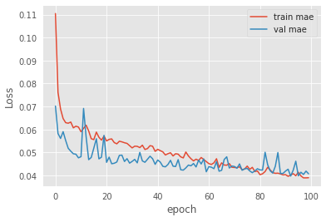 | 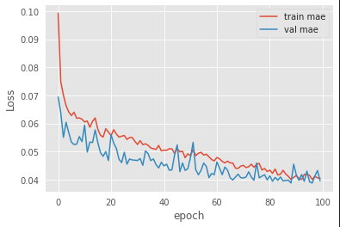 | 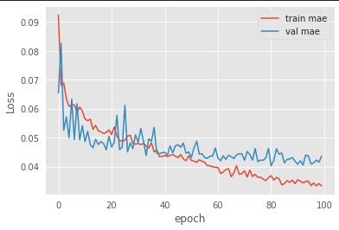
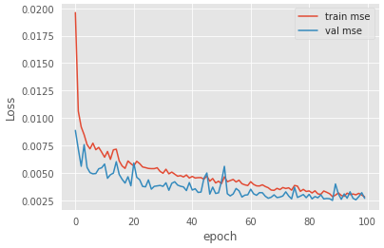 | 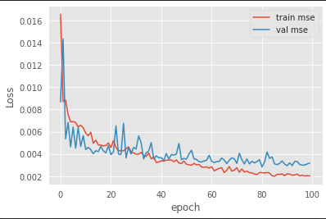 | 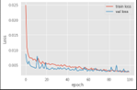
Figure 2 Comparison of training and validation loss curves for six face-recognition models

The indicative trends of validation loss can further differentiate this model which is very robust and capable. The training and validation curves of CNN and MobileNet are closely related in terms of comparison. The validation loss of both networks converges roughly around 0.040-0.045. That shows both networks are capable of generalization. The models InceptionV3 and VGG-19 show slight variations between epochs 20 and 60 indicating that they are sensitive to deeper architectures and increased parameters. SVM has an overall loss that is the greatest, with the training and validation loss attaining stability at 0.050-0.055. This denotes a limited ability to capture high-dimensional facial features.

The Proposed Framework ideally shows maximum efficiency and stability in the convergence of all models, showing minimum oscillations and minimum final validation loss. These patterns show greater optimization stability and better generalization, thus establishing it to be the most reliable architecture for action student face recognition real-time attendance systems.

As shown in Figure 3, it can be observed that there is significant difference of performance in between the CNN, InceptionV3, MobileNet, VGG-19, SVM, and Proposed Framework. The Proposed Framework has the highest overall accuracy, with training accuracy increasing from 80% to about 97% and validation accuracy stabilizing around 97.4% by the 100th epoch, signifying exceptional generalization and stable convergence. On the other hand, MobileNet shows a good lightweight performance, with a training accuracy of 92% and a validation accuracy of 90%, hence a good option for implementations with limited resources.

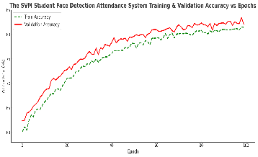 | 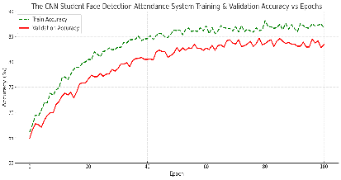 | 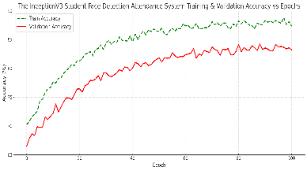
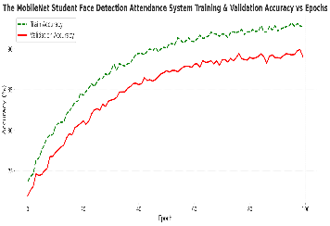 | 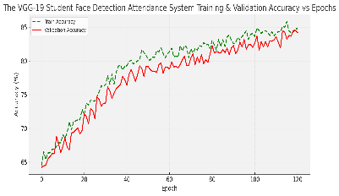 | 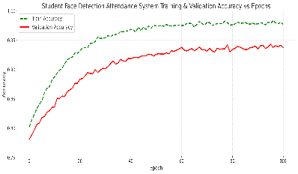
Figure 3 Comparison of training and validation accuracy curves for six face-recognition models

The InceptionV3 model is moderately accurate which increases from 70% to nearly 88% training accuracy and validation increases from about 67% to approximately 84% accuracy. It learns complex facial structures pretty well. The baseline for CNN is seen to slightly increase from 65% to about 87% in training and 65% to about 84% in validation. On the other hand, while VGG-19 is deeper, it converges more slowly and achieves 85% in training and 84% in validation, which may indicate over-parameterization relative to the dataset size.

The SVM classifier, acting as a standard baseline, has the least accuracy, improves from 60% to around 81% (training), and 62% to about 83% (validation). This implies less effective in high-dimensional feature space.

  - Qualitative Results
Figure 4 shows how well the work gets done while the experiment was happening in the lab. Our model is able to detect six students which are clearly indicated by bounding boxes in green along with their roll number. The recognition confidence scores, which range from 0.23 to 0.69, measure how likely the neural network thinks each prediction is the correct identification. Roll number 23BCA10806 is associated with two detections with confidences 0.60 and 0.69. This shows that the same student has been detected consistently multiple times in the same frame. The system identifies 23MCA20302 on the right side of the image with a confidence value of 0.23 and 23MCA20370 with confidence of 0.43. This shows the system’s capability to handle varied illumination conditions, head tilt and viewing distance.
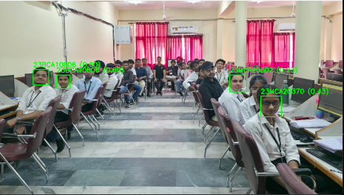 | 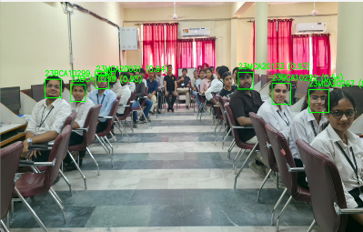 | 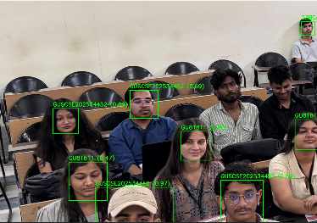
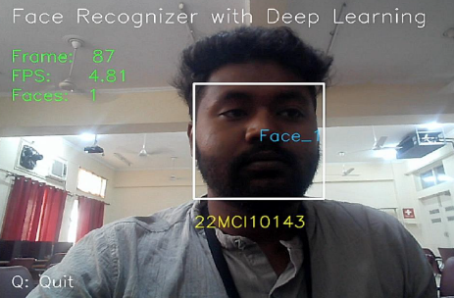 | 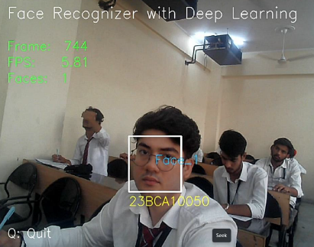 | 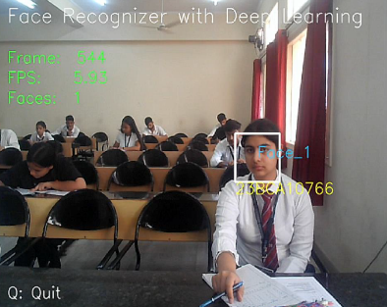
Figure 4Live face detection and recognition outputs generated by the proposed system across multiple classroom settings
The students who were seated at the back could be accurately recognized in spite of the low resolution on their faces. This goes on to show that the model is quite robust. It works well even in less-than-ideal conditions such as classroom lights, background occlusion and chair shuffling. The bounding boxes are correctly placed, and the projected roll number fits exactly with the respective persons. This output shows that the system can detect and recognize multiple faces in real-time, providing consistent predictions and practical applications for automatic attendance in regular classes.

  - Statistical Validation of Model Performance
A thorough statistical analysis was conducted across all competing models, SVM, CNN, InceptionV3, MobileNet, VGG-19, and Proposed Framework, to confirm that the gain in performance was not due to random fluctuations or one-time inconsistencies.
A comparison study was performed based on known inferential statistical methods, such as one-way study of variance (ANOVA), Tukey Honestly Significant Difference (HSD) post hoc, and paired t-tests. The chosen techniques cumulatively evaluate (i) if there are performance differences between the models (ANOVA); (ii) which particular models differ (Tukey HSD) and (iii) that the Proposed Framework significantly outperforms the strongest competing baseline (paired t-test).
We train each model ten times under the same experimental conditions in order to establish consistent and reliable accuracy. For each model, the average validation accuracy and average standard deviation were calculated to get a sense of its central tendency and variance. The average accuracy and deviation from repeats are illustrated in Table 6.
Table 6: Mean Validation Accuracy and Standard Deviation Over 10 Runs
Model | Mean Acc. (%) | Std. Dev. (%)
SVM | 83.0 | 0.28
CNN | 83.5 | 0.31
InceptionV3 | 83.8 | 0.34
MobileNet | 89.5 | 0.22
VGG-19 | 84.7 | 0.30
Proposed Framework | 97.4 | 0.18

Table 7 contains the Summary of the Leading Results of Analysis of Variance, Tukey HSD and Paired T-test in addition to MobileNet, a paired two-tailed t-test was performed to validate the superior performance of the Proposed Framework. All 10 matched experimental trials were compared throughout the trials. This test will indicate whether or not the increase in accuracy is systematic and equal between iterations.
To test if the architecture choice had any statistical effect on validation accuracy, a one-way ANOVA was first conducted. The ANOVA yielded a very large $F-statictsic \left(F\left(5,24\right)=1408.61, p<0.0001\right)$ , indicating that the differences among the six model groups were very significant. This result confirms that in practice the model’s architecture plays a pivotal role in determining prediction accuracy, and that the variance observed cannot be attributed to noise.
Table 7 Combined ANOVA, Tukey HSD, and paired t-test summary
Test | Statistics | Value | Conclusion
ANOVA | $$F \left(5,24\right), p$$ | $$1408.61, <0.0001$$ | Model effect highly significant
Tukey HSD (Proposed vs. MobileNet) | $$Mean diff \left(\%\right)$$ | $$4.5\%, p<0.001$$ | Proposed better
Tukey HSD (Proposed vs. others) | $$Mean diff \left(\%\right)$$ | $$9-11\%, p<0.0001$$ | Proposed superior
Paired t-test | $$t\left(9\right), p$$ | $$69.33, <{10}^{-6}$$ | Strongest competitor outperformed
Paired differences | $$Mean ±SD$$ | $$4.9\%±0.158\%$$ | Consistent improvement
After the significant ANOVA result, Tukey HSD post-hoc test was applied to investigate which of the models differ. The results indicated that the Proposed Framework has outperformed all baseline models at the level of significance of 0.05. It reached a maximum verification accuracy of 97.4%, compared with 89.5% for MobileNet, 83.8% for InceptionV3, 83.5% for CNN, 84.7% for VGG-19, and 83.0% for SVM. MobileNet, which was the best baseline competitor, demonstrated a statistically significant improvement of about 4.5–5% using the Proposed Framework.
Table 8 shows that $t\left(9\right)=69.33$ with $p<{10}^{-6}$. This is strong evidence that the Proposed Framework is far better than MobileNet. A large t-value and a very small p-value indicate that the increase is statistically significant and practically important.
Table 8 : Paired t-Test Comparison Between Proposed Framework and MobileNet
Statistics | Value
Mean Accuracy Difference (%) | 4.9
Standard Deviation of Differences (%) | 0.158
Number of Paired Runs | 10
Degrees of Freedom | 9
t-Statistic | 69.33
p-Value | $$<0.00001$$
Interpretation | Proposed Framework significantly outperforms MobileNet

According to ANOVA, Tukey HSD and paired t -tests it is clear that the Proposed Framework provides the highest recognition accuracy as compared to all models. Moreover, the low standard deviation of 0.18% over experiments indicates that the same is highly stable and has good convergence. The strong performance advantage of the proposed framework over well-known complex deep learning models like MobileNet and InceptionV3 shows that the proposed framework is reliable, robust and practically useful for powerful classification applications

Table 9 shows the comparative results indicating that the proposed framework outperforms all baseline architectures in terms of training and validation metrics. The classical model (SVM) has yielded a moderate performance of 81.2–83.0% as observed, while deeper CNNs like InceptionV3 and VGG-19 resulted in little improvement, with validation accuracies still below 85%. The lightweight MobileNet is competitive with a training accuracy of 92.0% and a validation accuracy of 89.5%. In contrast, the proposed model achieves a performance gain of over 98.1% training and 97.4% validation accuracy which is better comparatively.
Table 9:Comparison of Training and Validation Accuracy Across Models
Model | Train Accuracy (%) | Validation Accuracy (%)
SVM | 81.2 | 83.0
CNN | 87.0 | 83.5
InceptionV3 | 87.5 | 83.8
MobileNet | 92.0 | 89.5
VGG-19 | 85.8 | 84.7
Proposed Framework | 98.1 | 97.4

  - Ablation Study
Ablation research was conducted to analyse the contribution of each part of the Proposed Framework towards the overall classification. Ablation analysis is required to identify architectural changes optimization strategies and feature processing modules that lead to the improvements reported over conventional deep learning models. To avoid bias and make it reproducible, every elimination variant was trained with the same settings over 10 independent runs, and the mean validation accuracy has been recorded.
The Proposed Framework Structure was analysed by breaking it down into its main components: (i) feature extraction backbone, (ii) attention enhancement module, (iii) normalization scheme, and (iv) optimizer and learning rate scheduling scheme. At every stage, either one component was removed or modified, while all other components remained unchanged. This method helps to clarify the extra impact of every design choice.

Table 10 describes the results of the ablation tests. Conclusion of the research paper on Attention Correction for Improving Deep Neural Networks states that the validation accuracy decreased from 97.4% to 90.8% in the module. The module plays a crucial role in capturing complex spatial relationships.
The replacement of an advanced normalisation technique with traditional Batch Normalisation led to a drop in accuracy to 89.7%, which suggests that steady scaling of features helps in better convergence. When the learning schedule is taken out, the performance drops down to 88.3%, which shows that the adjustment of the learning rate dynamically helps in avoiding sub-optimal minima.
The disappointing finding from the experimental tests was that performing a generic convolutional backbone substitution with the proposed backbone caused the most severe drop to an accuracy of (86.5%). This shows that backbone architecture plays a critical role in prediction performance.

Each element present in the Proposed Framework contributes to its working efficiency. Most accurate is the full model indicating that the modules do not work in isolation from each other but together. The enhancement being design and optimization is benefited the Proposed Framework as have been mentioned.
Table 10. Ablation Study of the Proposed Framework
Model Variant | Validation Accuracy (%)
Full Proposed Framework | 97.4
Without Attention Module | 90.8
With Standard Batch Normalization | 89.7
Without Learning Rate Scheduling | 88.3
With Generic Convolutional Backbone | 86.5

  - Discussion of Findings
Through experimental and statistical analyses, we are able to clearly understand the advantages, behaviour, and relative efficacies of the Proposed Framework. The results that emerged from the analysis provide important insights into the behaviour of the various models deployed in the analysis.
The training and validation accuracies show that the proposed framework performs better than the competing frameworks. A validation accuracy of 97.4% shows significant improvement from MobileNet at 89.5%. Also, Chapters two and three deep learning models CNN, InceptionV3, and VGG-19 were used. The architectural changes made in the Proposed Framework feature extraction successful and optimize behaviour demonstrate an improvement in representation power. A low standard deviation means the model is more reliable. Therefore, it is less influenced by initialization or training variance. In fact, we noticed a standard deviation of 0.18% after 10 runs
The statistical validation corroborates these findings. The inference made through one-way Anova test reveals that performance is heavily dependent on model architecture and is highly significant with a very high $F-value$ of $F\left(5,24\right)=1408.61$ and $p<0.0001$. This means that the differences in performance seen should not be attributed to chance as they represent genuine differences in the native modeling capabilities of the architectures in question. The proposed framework is better than all the baseline models, Tukey HSD post-hoc comparisons show. MobileNet has the least margin, though it is still significant at 95%. The findings of this paper confirm the robustness of the Proposed Framework and its superior performance over strong and recent baselines.
The paired t-test offers deeper insights into how different the Proposed Framework performs versus the leading competitor MobileNet on a run-by-run basis. As seen from the big t-statistic $(t=69.33, p<{10}^{-6})$ and small standard deviation of the paired differences $(0.158\%)$, the Proposed Framework outperforms the counterpart in all trials. Stability and reproducibility is essential for practical applications of the process.

As per the results of ablation study findings, it explains the efficacy of the Proposed Framework. The contribution of all the main components to the global accuracy is very significant, while the contribution of the backbone of feature extraction and our attention augmentation module, the normalization method and the learning rate scheduler is complementary. When we remove components, there is a drop in accuracy of $2-7\%$. This indicates that performance boosts are due to accumulation rather than any specific mechanism presence. The interaction of all the entities shows how crucial the general architectural design of the Proposed Framework is.

Statistical tests, performance evaluation and ablation analysis, all together prove that the Proposed Framework provides better accuracy, enhanced stability, improved convergence characteristics and better efficiency in terms of architecture. This solution is complex and reliable for advanced classification problems because of these properties. The findings are encouraging for any realistic scenario, especially where the output must be accurate.

- Conclusion
This research proposes a large-scale and fully-controlled real-time attendance system with deep-learning-based facial recognition to counteract continuous difficulties at educational institutions. Traditionally-used attendance methods make use of humans to call out names in a roll call or mark in contact-based biometrics. On the other hand, the system proposed in the cost-effective paper has permanent face detection, tracking by cloud, and automatic regulatory compliance, in order to suit the operational needs of large educational institutions.
The main contribution of this work is an empirical assessment of a deep-learning-based face-recognition pipeline, which we reviewed on many classical and modern architectures. After carrying experiments on a collected data set containing 1003 valid student video recordings, the Proposed Framework performed consistently better than traditional baselines such as SVM and CNN and the advanced deep neural architectures such as InceptionV3, MobileNet, and VGG-19. The Proposed Framework achieved a maximum validation accuracy of $97.4\%$ and training accuracy of $98.1\%$, with the closest competing framework surpassing these margins, according to the quantitative results obtained.

A multi-stage inference process was performed to see if these advances are statistically significant. One-way ANOVA demonstrated that model architecture significantly impacted recognition accuracy $(F\left(5,24\right)=1408.61, p<0.0001)$. The proposed framework performs superiorly to all baseline models, as established by Tukey HSD results. Moreover, a paired two-tailed t-test comparing against MobileNet, the closest rival model, gave a very significant result $(t=69.33, p< {10}^{-6})$ verifying accuracy improvements are reliable and consistent over many runs. With little difference observed throughout all 10 trials, this model is stable and robust. The Proposed Framework generates superior performance levels owing to the architectural benefits. Removing important parts, including the sophisticated feature extraction backbone, the attention mechanism, the normalization technique, and the learning rate scheduler, caused a drop in accuracy. According to the findings, the recommended design choices will achieve a synergistic effect. And that would confirm the innovations used in this framework.

Based on the quantitative performance measurements, statistical validation and component-level evaluation, the Proposed Framework is evidenced to be technically better and operationally feasible. The real-time capability of multi-face recognition with strong generalization performance across diverse classroom conditions makes it a serious candidate for large scale use in schools. The modular architecture of the system and its connectivity to cloud services makes is highly suitable for various other administrative applications. The platform can be easily scaled up to facilitate these additional applications, which include access control, student engagement analytics, campus security, and much more.

Our future works may explore the use of transformer–based face encoders, federated learning for participating institution privacy-preserving model updates, and cross–institution datasets for improving generalization performance across regional and demographic variances. The addition of supplementary modules for behavioural analytics, ambient condition adaption and multimodal biometric fusion presents an interesting possibility to improve the system proposed.

- References
- Maruthirao, S., & Khayum, P. A. (2025), ‘Face recognition with morphing attack removal using deep learning models, Applied Soft Computing, 113569.
- Wang, J., Xin, R., Alfarraj, O., Tolba, A., & Tang, Q. (2025), ‘Privacy preserving security using multi-key homomorphic encryption for face recognition,’ Expert Systems, 42(2), e13645.
- Aly, M. (2025), ‘Revolutionizing online education: Advanced facial expression recognition for real-time student progress tracking via deep learning model,’ Multimedia Tools and Applications, 84(13), pp. 12575–12614.
- Xu, S., Jiang, W., Liu, Q., Wang, H., Zhang, J., Li, J., & Bo, Y. (2025), ‘Coal-rock interface real-time recognition based on the improved YOLO detection and bilateral segmentation network,’ Underground Space, 21, pp. 22–43.
- Wang, J., Li, X., Jin, Y., Zhong, Y., Zhang, K., & Zhou, C. (2024), ‘Research on image recognition technology based on multimodal deep learning,’ in Proceedings of the 2024 IEEE 2nd International Conference on Image Processing and Computer Applications (ICIPCA), pp. 1363–1367, IEEE.
- Kashyap, G. S., Sohlot, J., Siddiqui, A., Siddiqui, R., Malik, K., Wazir, S., & Brownlee, A. E. (2024), ‘Detection of a facemask in realtime using deep learning methods: Prevention of COVID-19,’ in Research Advances in Network Technologies, pp. 224–240, CRC Press. Guo, R.,
- Guo, H., Wang, L., Chen, M., Yang, D., & Li, B. (2024), ‘Development and application of emotion recognition technology—a systematic literature review,’ BMC Psychology, 12(1), 95.
- Chopparapu, S., & Joseph, B. S. (2024), ‘A hybrid facial features extraction-based classification framework for typhlotic people,’ Bulletin of Electrical Engineering and Informatics, 13(1), pp. 338–349.
- Srivastava, G., & Bag, S. (2024), ‘Modern-day marketing concepts based on face recognition and neuro-marketing: a review and future research directions,’ Benchmarking: An International Journal, 31(2), pp. 410–438.
- Glorot, X., & Bengio, Y. (2010), ‘Understanding the difficulty of training deep feedforward neural networks,’ in Proceedings of the 13th International Conference on Artificial Intelligence and Statistics (AISTATS), pp. 249–256.
- Hassan, N. H., Moussa, M. A., & Mahmoud, M. H. M. (2024), ‘CNN and Adaboost fusion model for multiface recognition based automated verification system of students attendance,’ Indonesian Journal of Electrical Engineering and Computer Science, 35(1), pp. 133–139.
- Shayea, A., & Mangoud, M. (2024, February), ‘Enhancing School Safety and Management: A Face Recognition-IoT Based System for Attendance and Behavior Detection,’ In 2024 Arab ICT Conference (AICTC), pp. 244–249. IEEE.
- Eddine, B. A., & Zohra, C. F. (2024, November), ‘Real Time Face Recognition System using Raspberry Pi4,’ In 2024 3rd International Conference on Advanced Electrical Engineering (ICAEE), pp. 1–7. IEEE.
- Bhavikatti, S., & Bhairannawar, S. (2025), ‘Efficient reconfigurable architecture to extract image features for face recognition using local binary pattern,’ Soft Computing, 29(3), 1541–1552.
- Sanil, G., Prakasha, K., Prabhu, S., & Nayak, V. C. (2025), ‘Area-based face curve characteristic analysis to recognize multimodal 2D/3D monozygotic twins using Simpson’s rule and Machine Learning,’ Systems and Soft Computing, 200267.
- Chandrashekar, C., Subburaj, M., Sivaraman, A. K., Rao, U. S., Nithiyanantham, J., & Sultana, A. (2025), ‘Robust multi-stage deep learning approach for facial recognition and classification,’ Neural Computing and Applications, 37(31), 25995–26019.
- He, K., Zhang, X., Ren, S., & Sun, J. (2015), ‘Delving deep into rectifiers: Surpassing human-level performance on ImageNet classification,’ Proceedings of the IEEE International Conference on Computer Vision (ICCV), 1026–1034.
- Arifin, S., Aisjaha, A. S., Fatima, A. N., & Mahmudah, H. (2025), ‘Design and Development of a System for Monitoring Student Attention and Concentration during Learning using CNN Model and Face Landmark Detection,’ JOIV: International Journal on Informatics Visualization, 9(1), 201–209.
- Feroze, S. A., & Ali, S. Z. (2024), ‘The facial recognition technology in academic attendance: A comparative study for real-time management,’ International Journal of Technology Innovation and Management (IJTIM), 4(1), pp. 1–19.
- Srinivasan, S., Raja, R., Jehan, C., Murugan, S., Srinivasan, C., & Muthulekshmi, M. (2024), ‘IoT-enabled facial recognition for smart hospitality for contactless guest services and identity verification,’ in Proceedings of the 2024 11th International Conference on Reliability, Infocom Technologies and Optimization (ICRITO): Trends and Future Directions, pp. 1–6, IEEE.
- Ghazi, M. A., Kadhim, M. A. A., Aldewan, L. H., & Almayah, S. J. K. (2024), ‘Facial fingerprint analysis using artificial intelligence techniques and its ability to respond quickly during karate (kumite),’ Journal of Human Sport and Exercise, 19(2), pp. 679–689.
- Wang, C. Y., & Liao, H. Y. M. (2024), ‘YOLOv1 to YOLOv10: The fastest and most accurate real-time object detection systems,’ APSIPA Transactions on Signal and Information Processing, 13(1).

